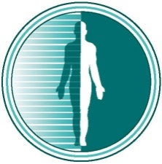
Lake Medical Imaging
& Breast Center at The Villages, LLC
Accredited by the American College of Radiology

POSITION:
- Opportunity to join one of the leading private practices in Central Florida under the umbrella of University of Florida Health
- Highly desirable opportunity to join a tight knit, supportive and friendly group
- Evening and weekend call shared, no overnight call. Post-call days are off
- Opportunity to work some day and call rotations from home
- Full range of benefits, competitive compensation and partnership track. Plenty of moonlight opportunities if desired
- Can reside in the suburbs of Orlando
ABOUT THE PRACTICE:
Lake Medical Imaging is a physician owned and operated private practice, based in The Villages and Leesburg FL. We provide exclusive diagnostic and interventional radiology services to six outpatient imaging centers and two hospitals including UF Health The Villages, and UF Health Leesburg. We are an independent practice comprised of 24 diagnostic radiologists and 6 interventional radiologists. The group is highly respected by the hospital and administration and enjoys long term stability.
REQUIREMENTS:
- Board certified/eligible by American Board of Radiology or the American Osteopathic Board of Radiology or Board certified in Diagnostic Radiology
- A one-year post residency fellowship in Neuroradiology.
- Eligible to obtain a Florida Medical License
Email CV to jfloyd@lakemedicalimaging.com or call (352) 365-2583.

